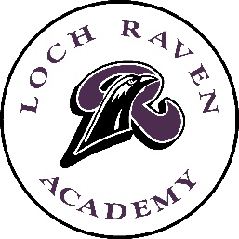
Directions for Summer Enrichment Assignments

Greetings Parents and Guardians of Loch Raven Technical Academy’s Students,
Summer enrichment assignments for students in our General Program (except for students taking Algebra) are not mandatory, they serve as enrichment assignments. We strongly encourage students to complete them. We find that students who complete assignments over the summer come back more prepared for the next school year and need less re-teaching in the fall.
Students who complete and submit these assignments to the appropriate teacher in the Fall will receive credit for completing them.
Magnet students should complete the assignment for their chosen magnet program. However, if students do not complete them over the summer, they will have time in the Fall once school has started to complete these assignments.
Please contact the main office at (443) 809-3518 between 8:00am and 3:00pm if you have any questions.

Thanks so much,
Mrs. Johnson
Principal

